CCNA Beginner Packet Tracer Lab
Static Routing Between Cafe01-RT1 and Fallout-RT1
Network design, addressing, cabling, configuration, and validation
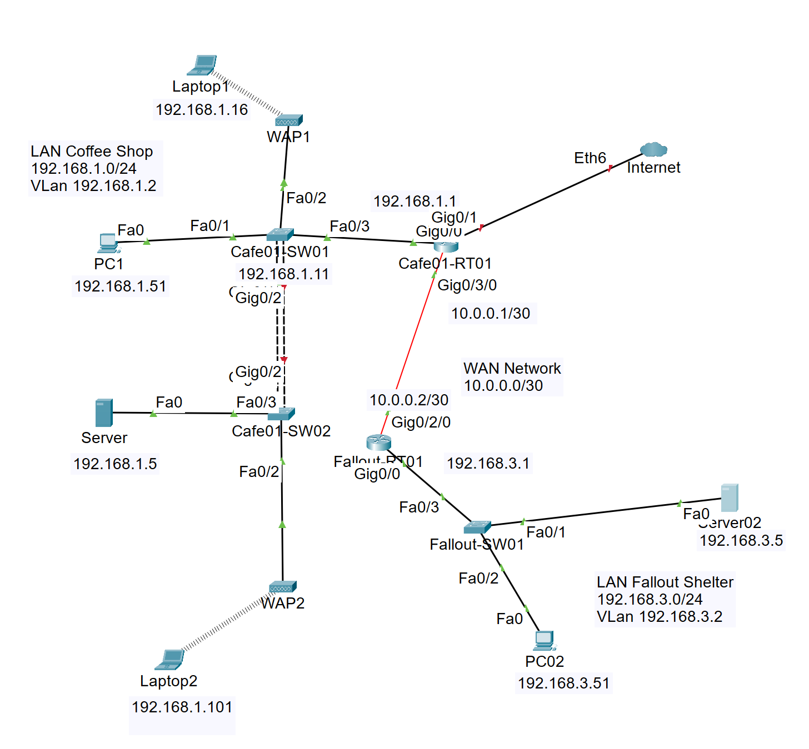
Figure 1. Coffee Shop and Fallout Shelter static-routing topology.

1. Learning objectives
- Build the topology shown in the uploaded diagram.
- Configure the Coffee Shop LAN, the Fallout Shelter LAN, and the 10.0.0.0/30 WAN link.
- Create reciprocal static routes between Cafe01-RT1 and Fallout-RT1.
- Verify local connectivity, WAN connectivity, end-to-end communication, ARP learning, and routing-table entries.

2. Addressing plan
Device | Interface | IP address | Mask | Default gateway | Role
PC1 | Fa0 | 192.168.1.51 | 255.255.255.0 | 192.168.1.1 | Coffee Shop PC
Laptop1 | Wireless0 | 192.168.1.16 | 255.255.255.0 | 192.168.1.1 | Wireless client
Server | Fa0 | 192.168.1.5 | 255.255.255.0 | 192.168.1.1 | Coffee Shop server
Laptop2 | Wireless0 | 192.168.1.101 | 255.255.255.0 | 192.168.1.1 | Wireless client
Cafe01-SW01 | VLAN 1 | 192.168.1.11 | 255.255.255.0 | 192.168.1.1 | Switch management
Cafe01-RT1 | LAN interface | 192.168.1.1 | 255.255.255.0 | - | Coffee Shop gateway
Cafe01-RT1 | WAN interface | 10.0.0.1 | 255.255.255.252 | - | WAN to Fallout-RT1
Fallout-RT1 | WAN interface | 10.0.0.2 | 255.255.255.252 | - | WAN to Cafe01-RT1
Fallout-RT1 | LAN interface | 192.168.3.1 | 255.255.255.0 | - | Fallout gateway
Fallout-SW01 | VLAN 1 | 192.168.3.2 | 255.255.255.0 | 192.168.3.1 | Switch management
Server02 | Fa0 | 192.168.3.5 | 255.255.255.0 | 192.168.3.1 | Fallout server
PC02 | Fa0 | 192.168.3.51 | 255.255.255.0 | 192.168.3.1 | Fallout PC

3. Place and cable the devices
- Place Cafe01-RT1 and Fallout-RT1 in the center of the workspace.
- Place Cafe01-SW01 and Cafe01-SW02 on the Coffee Shop side.
- Place Fallout-SW01 on the Fallout Shelter side.
- Place the PCs, servers, WAPs, and laptops as shown in the diagram.
- Connect PC1 to Cafe01-SW01 Fa0/1.
- Connect WAP1 to Cafe01-SW01 Fa0/2.
- Connect Cafe01-SW01 Fa0/3 to the LAN interface on Cafe01-RT1.
- Connect Cafe01-SW01 to Cafe01-SW02 using one trunk or an EtherChannel if two links are used.
- Connect Server to Cafe01-SW02 Fa0/3 and WAP2 to Fa0/2.
- Connect Cafe01-RT1 to Fallout-RT1 across the 10.0.0.0/30 WAN.
- Connect Fallout-RT1 to Fallout-SW01 Fa0/3.
- Connect Server02 to Fallout-SW01 Fa0/1 and PC02 to Fa0/2.

4. Configure the end devices
Use Desktop > IP Configuration on each PC, laptop, and server. Enter the address, mask, and gateway from the table above.

5. Configure Cafe01-RT1
enable
configure terminal
hostname Cafe01-RT1
no ip domain-lookup
interface gigabitethernet0/0
description Coffee Shop LAN
ip address 192.168.1.1 255.255.255.0
no shutdown
exit
interface gigabitethernet0/3/0
description Static WAN to Fallout-RT1
ip address 10.0.0.1 255.255.255.252
no shutdown
exit
ip route 192.168.3.0 255.255.255.0 10.0.0.2
end
copy running-config startup-config

6. Configure Fallout-RT1
enable
configure terminal
hostname Fallout-RT1
no ip domain-lookup
interface gigabitethernet0/2/0
description Static WAN to Cafe01-RT1
ip address 10.0.0.2 255.255.255.252
no shutdown
exit
interface gigabitethernet0/0
description Fallout Shelter LAN
ip address 192.168.3.1 255.255.255.0
no shutdown
exit
ip route 192.168.1.0 255.255.255.0 10.0.0.1
end
copy running-config startup-config

7. Configure Cafe01-SW01
enable
configure terminal
hostname Cafe01-SW01
interface vlan 1
ip address 192.168.1.11 255.255.255.0
no shutdown
exit
ip default-gateway 192.168.1.1
interface fa0/1
description PC1 - 192.168.1.51
switchport mode access
switchport access vlan 1
spanning-tree portfast
no shutdown
exit
interface fa0/2
description WAP1
switchport mode access
switchport access vlan 1
spanning-tree portfast
no shutdown
exit
interface fa0/3
description Uplink to Cafe01-RT1
switchport mode access
switchport access vlan 1
no shutdown
exit
end
copy running-config startup-config

8. Configure Fallout-SW01
enable
configure terminal
hostname Fallout-SW01
interface vlan 1
ip address 192.168.3.2 255.255.255.0
no shutdown
exit
ip default-gateway 192.168.3.1
interface fa0/1
description Server02 - 192.168.3.5
switchport mode access
switchport access vlan 1
spanning-tree portfast
no shutdown
exit
interface fa0/2
description PC02 - 192.168.3.51
switchport mode access
switchport access vlan 1
spanning-tree portfast
no shutdown
exit
interface fa0/3
description Uplink to Fallout-RT1
switchport mode access
switchport access vlan 1
no shutdown
exit
end
copy running-config startup-config

9. Remove dynamic routing if it already exists

On both routers
enable
configure terminal
no router eigrp 1
end
show ip protocols

10. Verify interfaces

On both routers
show ip interface brief
show interfaces description
Expected: all used router interfaces are up/up.

11. Verify static routes

On Cafe01-RT1
show ip route
show ip route 192.168.3.0
Expected: S 192.168.3.0/24 via 10.0.0.2

On Fallout-RT1
show ip route
show ip route 192.168.1.0
Expected: S 192.168.1.0/24 via 10.0.0.1

12. Test connectivity

WAN test
Cafe01-RT1# ping 10.0.0.2
Fallout-RT1# ping 10.0.0.1

Local tests
PC1> ping 192.168.1.1
PC1> ping 192.168.1.11
PC1> ping 192.168.1.5
PC02> ping 192.168.3.1
PC02> ping 192.168.3.2
PC02> ping 192.168.3.5

End-to-end tests
PC1> ping 192.168.3.51
PC1> ping 192.168.3.5
PC02> ping 192.168.1.51
PC02> ping 192.168.1.5

13. Trace the route

From PC1
tracert 192.168.3.51
Expected path: Cafe01-RT1, Fallout-RT1, then PC02.

14. Inspect ARP and MAC learning

On PCs
arp -a

On switches
show mac address-table
show interfaces status

On routers
show arp
show ip route

15. Completion checklist
☐ All interfaces are correctly addressed and up/up.
☐ Cafe01-RT1 has a static route to 192.168.3.0/24.
☐ Fallout-RT1 has a static route to 192.168.1.0/24.
☐ The two routers can ping each other across 10.0.0.0/30.
☐ PC1 can ping PC02 and Server02.
☐ PC02 can ping PC1 and the Coffee Shop server.
☐ tracert shows the two-router path.
☐ ARP and MAC tables contain learned entries.
☐ All configurations are saved.

